**FIGURES**

**Fig. 1**

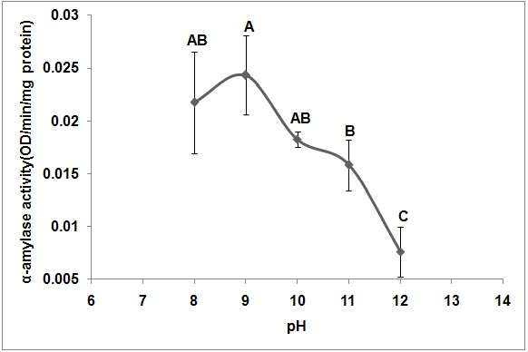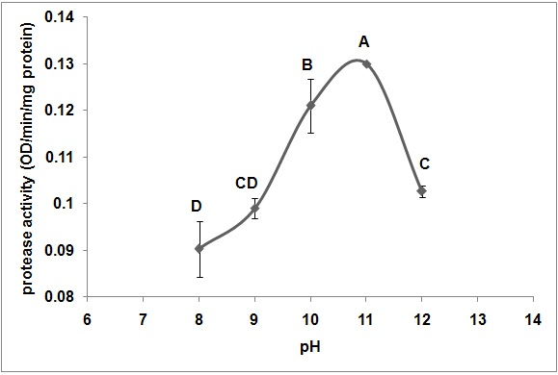

**(a) (b)**

**Fig. 2**

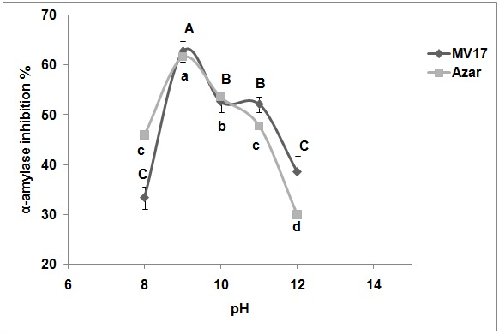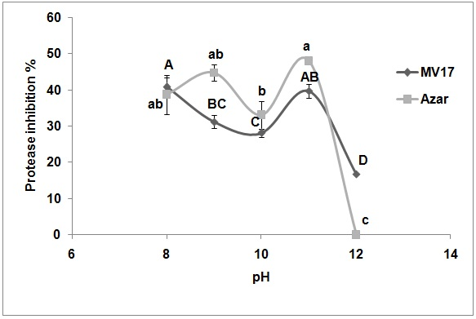

**(a) (b)**

**Fig. 3**

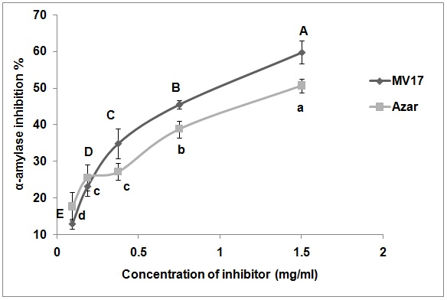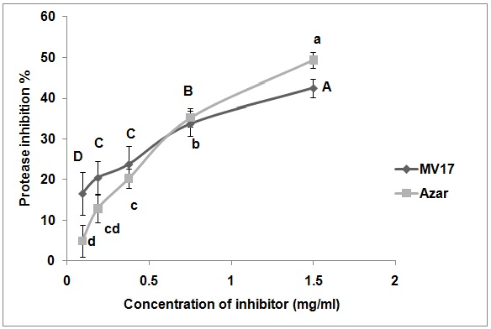

**(a) (b)**

**Fig. 4**

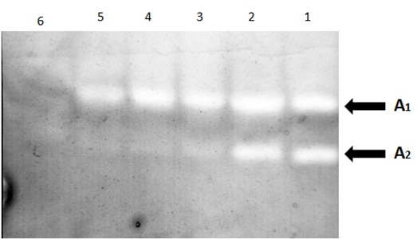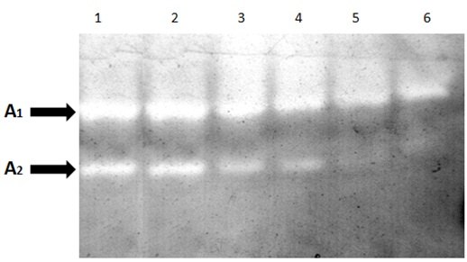

**(a) (b)**

**Fig. 5**

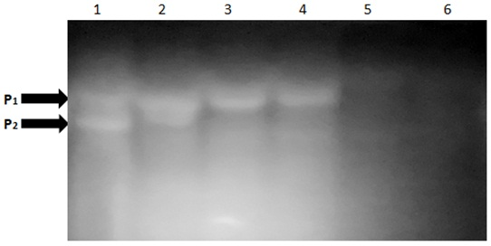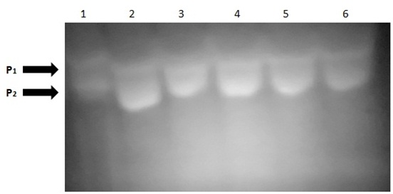

**(a) (b)**

**FIGURE LEGENDS**

**Fig. 1.** The effect of pH on α-amylase (a) and protease activities (b) of potato tuberworm. Means followed by the same letters are not significantly different by Tukey’s test (*P*<0.05).

**Fig. 2.** Theeffect of pH on inhibition of potato tuberworm α-amylase (a) and protease (b) by extracts from MV17 and Azar. Means followed by the same letters are not significantly different by Tukey’s test (*P*<0.05).

**Fig. 3.** Inhibition of potato tuberworm α-amylase (a) and protease (b) by different concentrations of MV17 and Azar. Means followed by the same letters are not significantly different by Tukey’s test (*P*<0.05).

**Fig. 4.** In gel inhibition assay of the effect of different concentrations of plant extracts on the α-amylase of potato tuberworm using 0.5% starch as substrate. Lane numbers are as follow: (1) enzyme extract with no inhibitor, (2) 0.093 mg/ml, (3) 0.187 mg/ml, (4) 0.375 mg/ml, (5) 0.75 mg/ml, (6) 1.5 mg/ml protein of extract from MV17 (a) and Azar (b).

A1: α-amylase first isozyme

A2: α-amylase second isozyme

**Fig. 5.** In gel inhibition assay of the effect of different concentrations of plant extracts on the protease of potato tuberworm using 1% gelatin. Lane numbers are as follow: (1) enzyme extract with no inhibitor, (2) 0.093 mg/ml, (3) 0.187 mg/ml, (4) 0.375 mg/ml, (5) 0.75 mg/ml, (6) 1.5 mg/ml protein of extract from MV17 (a) and Azar (b).

P1: α-amylase first isozyme

P2: α-amylase second isozyme